**Company Profile**

**Binangonan Lakeview Hospital**

Binangonan Lakeview Hospital Incorporated is a private corporation founded and registered with the Securities and Exchange Commission (SEC) in November 2011. A group of doctors and their friends had a vision to put up a healthcare facility in Binangonan, Rizal that will provide a high qualtiy healthcare service for the community and nearby towns. Sixty (60) percent of the stakeholders are practitioners in the

province who are specialists in their respective fields.

Construction of the hospital building situated in a 2, 158 square meter lot, took almost two (2) years, taking in consideration and strictly following all the Department of Health mandated requirements for a hospital facility.

BLH formally opened as a 30 bed capacity Secondary 2nd Level hospital on October 3, 2014 immediately after the issuance of DOH License to Operate (LTO). After three years, BLH is now an 88-bed capacity and has leveled up to a tertiary hospital.

​

At the moment BLH operates 24 hours, 7 days a week and an accredited partner of Philippine Health Insurance Company (PHIC).

**Mission**

A community of professional healthcare providers advocating competent, ethical and compassionate healing.

**Vision**

We are the Pioneers, the Leaders of Quality healthcare service in the region

**Core Values**

Teamwork  
Integrity  
Professionalism  
Service Excellence  
Social Responsibility

Services Offered

Medical and Surgical Clinics

Breast Care Clinic:

Mammogram / Breast Ultrasound

Dental / Panoramic X-ray

Obstetrics and Gynecology Clinics

Pediatric Clinics

ENT Clinic / Hearing Screening Test / Ophtalmology / Cataract Surgery

CT Scan / CT Guided Biopsies

X-ray and Ultrasound

Hemodialysis Center

Pharmacy – 24hr. Service

Tertiary Laboratory – 24 hr. Service

Emergency Medical Services / Ambulance

Physical Rehabilitation Unit

Endoscopy Unit

Oncology Unit

Adult Intensive Care Unit

Neonatal Intensive Care Unit

Outborn Unit

Respiratory Therapy Unit

Memory Screening Test

2D Echo w/ Color Doppler

Diabetes and Nutrition Clinic

Animal Bite Center

There are also critical cases services like Intensive Care Unit, Dialysis Center and Physical Rehabilitation Clinic. BLH prides itself with its digital Mammography which is first in the area, complemented by a breast care clinic manned by competent and highly skilled surgeons.

Organizational Chart

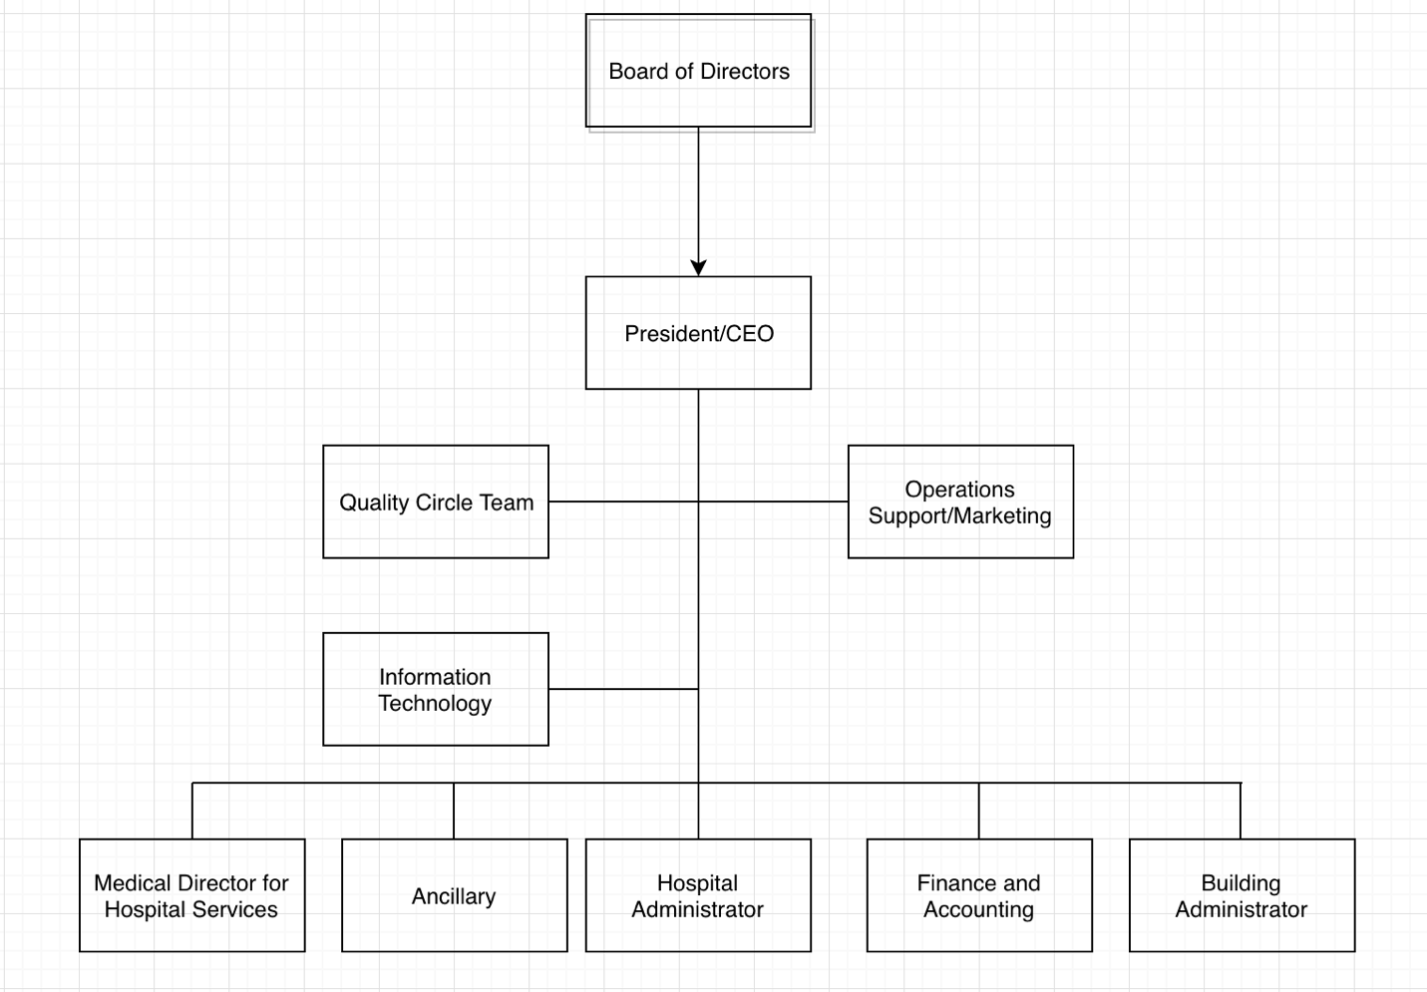

Department / Unit

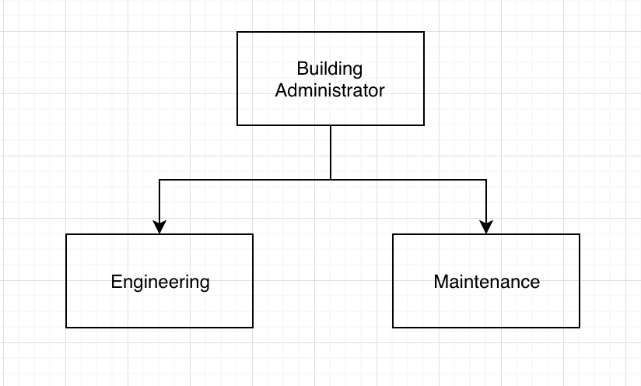

**Present System**

Users of Present System

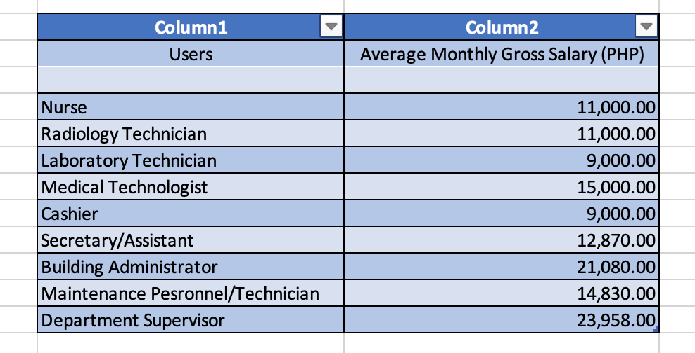

*Note: Some of the given average Monthly Gross Salary were roughly estimated by the company representative of the hospital as this particular subject is confidential.*

**List of Departments and Venues of the Present System**

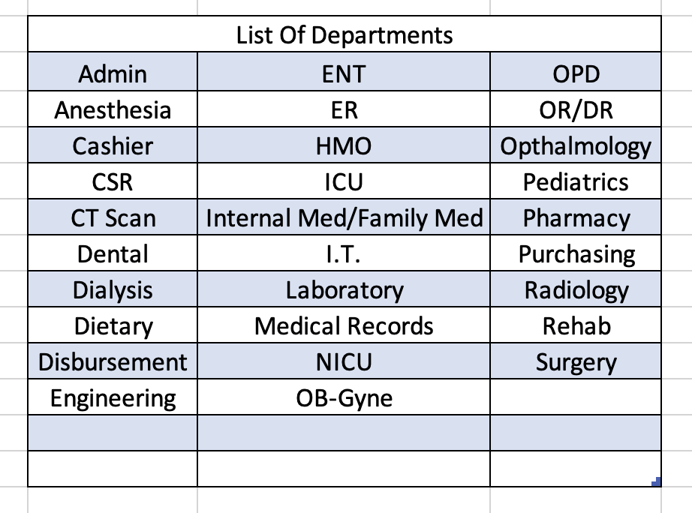

*Note: The departments that are listed are provided by the Admin.*

**Cost of Materials**

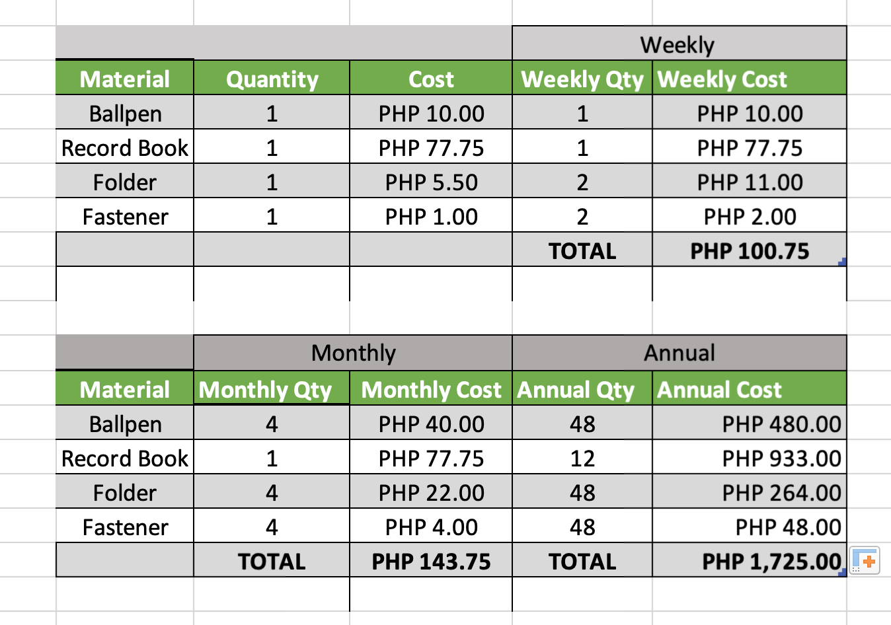

**Cost of Forms**